1. Install i-TRiLOGI 7.2 build 04 software.
2. Connect the PLC to the PC using a USB cable.
3. Start up the “PID_201_GFS_Adam_7_5_4p_pump_11” program.
4. Upload the program to the PLC by clicking the UPLOAD button:

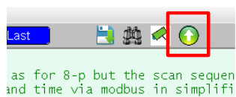

1. Click Configure Serial Port button to setup the port:

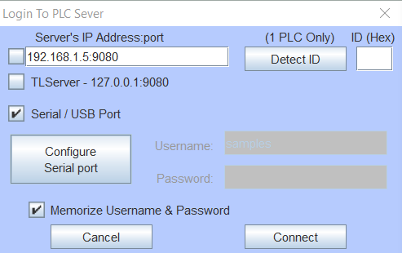

1. Configure to COM5 port and using Detect ID button to make sure the device is connected.

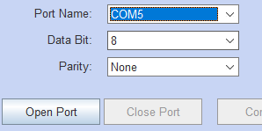

1. Click the Connect button and Click Yes to transfer and overwrite PLC’s program.

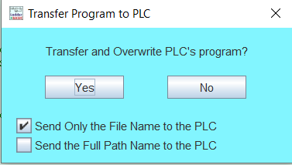

1. After the program is successfully uploaded (~2 minutes), make sure to click Reset button to reset the PLC.